**Eagle Board Layout Tutorial**

## Introduction

I the previous Eagle tutorial, we went through the basic steps of creating a schematic in the Eagle Schematic Capture program for a simple circuit. In this project, we use the board layout tool of Eagle to create a layout for a Printed Circuit Board (PCB). We will then go through the steps of ordering the boards to be fabricated. We will then assemble these boards in our last workshop lesson.

## Discussion Overview

Capturing a design’s schematic is the first step in creating a physical and functional board. Physical boards where physical components can be mounted on are called Printed Circuit Boards or PCBs.

As the name implies, a PCB has the desired circuit “printed” on it. This means that the physical board will contain locations where parts/components (like resistors or capacitors) can be soldered onto the board. The board will also contain physical copper traces for all the nets in the schematic that connect the parts.

Figure 1 is an example of an assembled printed circuit board.

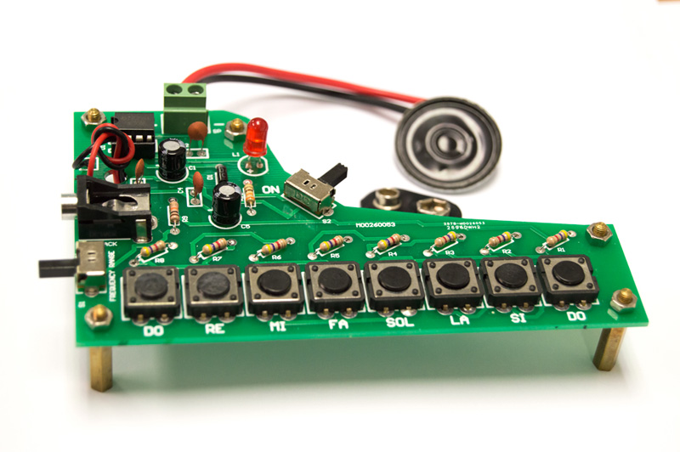

Figure 1 – Example of an Assembled PCB

Eagle, in addition to providing a schematic capture tool, also allows designers to create a board layout which is an electronic version of how a PCB would look. In the rest of this worksheet, we will go through a simple tutorial of Eagle’s board layout commands to create the layout from the schematic for the design of your choosing.

## Procedure

The following steps will guide you through creating a board layout for the DIY Piano. Figure 2 gives an example layout for this design. Your board layout might look different based on how and where you decide to place your components and how to connect the traces between those components.

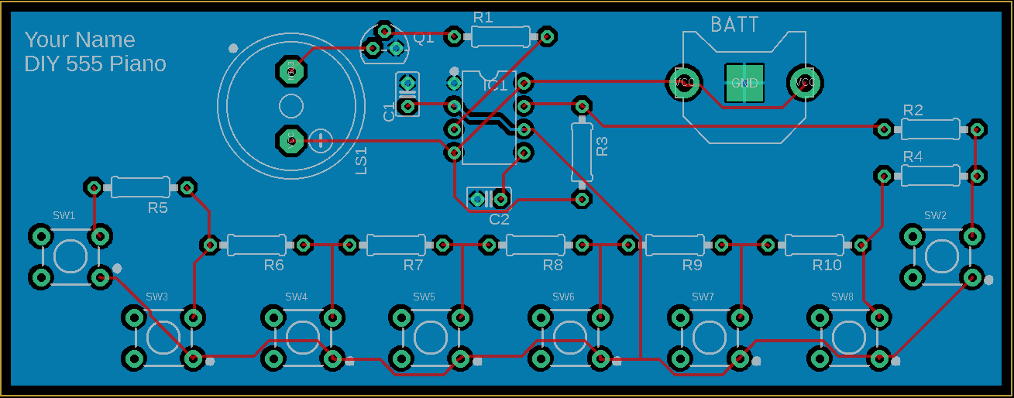

Figure 2 – DIY Piano Board Layout

1. Clone <https://github.com/League-EE/EE-Workshop> to your desktop.
2. Update your repo by executing the following commands in a command window from the EE-Workshop folder created on your desktop
   1. git fetch upstream
   2. git pull upstream master  
        
      *Note: Above layout is available as a .png image file for your reference in the folder EE-Workshop/Lesson 4/Eagle/DIYpiano folder.*
3. Open the DIYpiano schematic that you created in last week’s class. It should look similar to the one below.  
     
   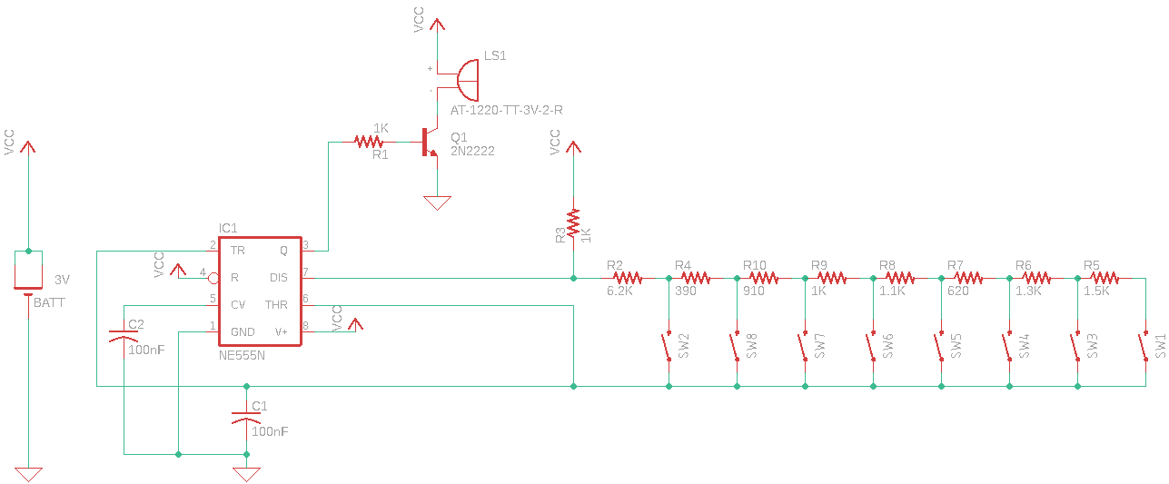
4. Eagle automatically links schematics and board layouts. The first step in doing so is to click on the “Generate/switch to board” button  at the top of the schematic capture window.
5. Doing so will open a dialogue window letting you know that a board does not exist and asking you if you’d like to create one. Click “Yes”.  
     
   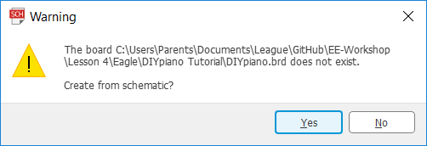
6. This will open up a new board layout window with a “bare” board whose size, by default, is set to 160mm x 100mm. Note that, the origin (location 0, 0) of the board is to the bottom left.  
   The part outlines for all the components in your design will also be placed lumped together outside and to the left of the board as shown below.  
     
   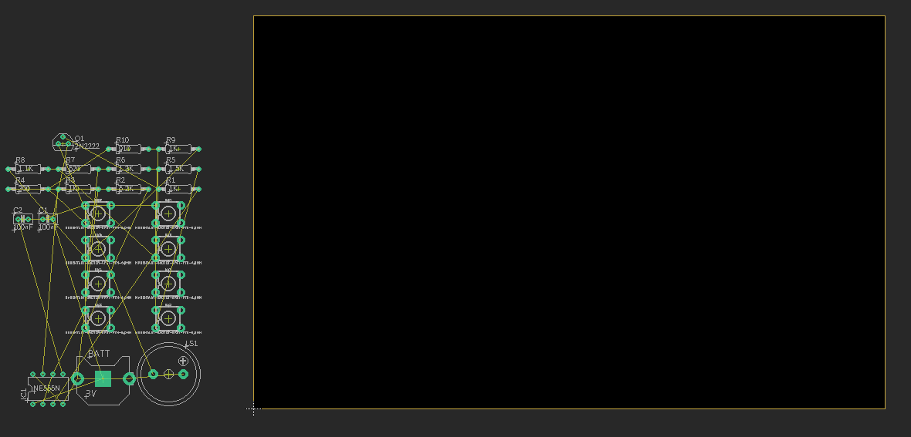  
   You will also notice the yellow lines between the component outlines. These are called “air wires” and represent all the connection nets in your schematic.
7. Placing parts  
   We will now attempt to place the components inside the board area by moving them. Note that, even though Eagle starts by placing all the parts outside of the board, the free version of Eagle does not allow you to move the parts outside the board. Once you move a part, it will need to be placed inside the board outline.
   1. Just like in the schematic window, in order to move a part, click on the move icon , and then click on the part that you want to move.
   2. Move the part to the area of the board that you’d like to place and left click again to place the part there.  
        
      *Note that, while moving a part, you can right click to rotate the part or center click to flip the part horizontally.  
        
      In placing the parts, you’d want to make sure the “air wires” are as short as possible between the parts they are attached to. Also, you’d want to orient the parts in such a way as to minimize crossovers of the “air wires”. The example below shows the speaker and BJT transistor placed close to each other where the distance between the emitter of the transistor and the negative lead of the speaker is minimized.*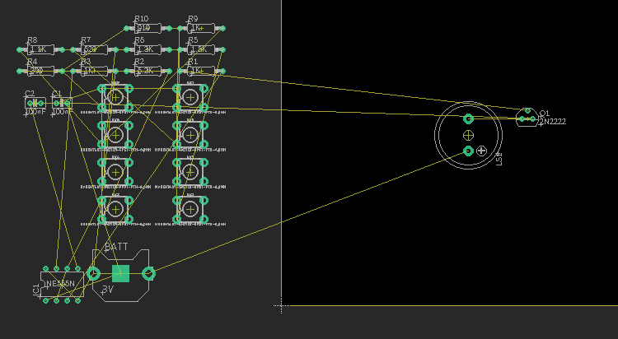
   3. Move and place all the parts onto your board. You can use Figure 2 as a reference. As you place parts, you can periodically click on the “Ratsnest” icon  to better see the connections between the parts.
   4. Once you have place all the parts, your board might look similar to the one in Figure 3.  
        
      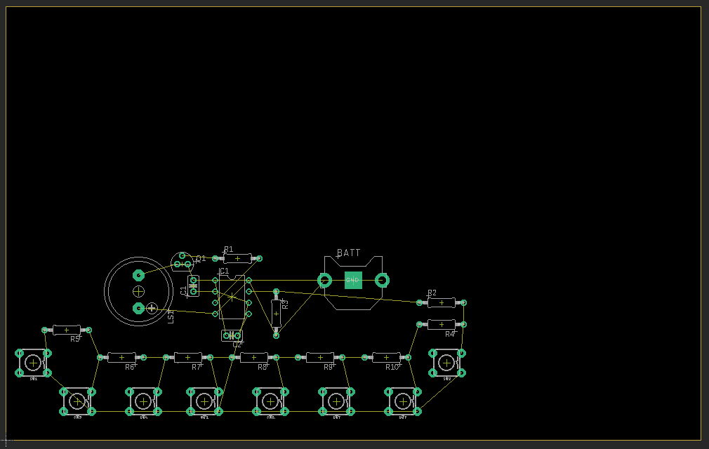

Figure 3 - Placed but Unrouted Board

* 1. At this point, click on the “Ratsnest” icon to redraw all the “air wires” in the design.

1. Resizing the board  
   Now that all the parts have been placed, the board can be resized to better fit the actual space needed.
   1. In order to move the board outline, click on the “Move” icon , and then click on the top outline of the board to move it down.  
        
      *Make sure that the two vertical outlines on the left and right are still perfectly vertical after you have moved the top outline down.*
   2. To move the right vertical outline, click on the line and move it closer to the left. Click again to place the outline once you are satisfied with its position. Now, your board should look similar to the one below.  
        
      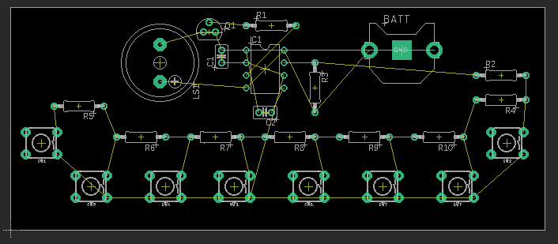
2. Layers  
   In this section, we introduce layers. Any PC board consists of at least a top layer and a bottom layer. For our simple board above, we will use only these two layers. Additionally, the free version of Eagle only supports top and bottom layers.  
   The top and bottom layers are where the components are placed. As it can be seen from our example above, all of our components are placed on the top layer. In additon to the components, top and bottom layers can contain copper traces corresponding to the nets in the schematic. More complex boards might have many other layers for routing the copper traces. They might also have some layers dedicated only to GND or Power.  
   In additon to these “physical” layers, board layout tools define other “virtual” layers where other aspects or features of the design might reside. Below is a partial list of the layers in our design. We are listing only the layers that are needed for our simple design.
   1. In order to change the characteristics of any layer, you can click on the “Layers” icon  which will open the “Layers” dialogue window.  
        
      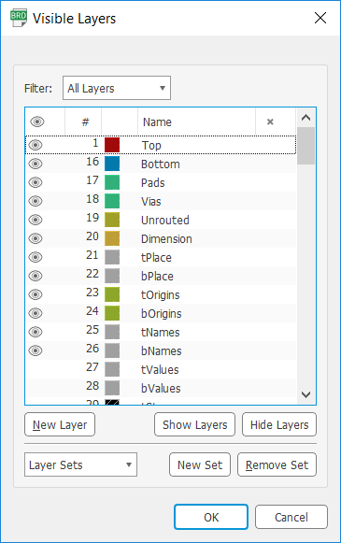
   2. Top & Bottom Layers: These were defined above. They are designated as layer numbers 1 & 16 respectively. In the window above, the color associated with the top layer is red ; any trace on the top layer, therefore, will be highlighted in red. The color associated with the bottom layer is light blue .
   3. Pads Layer: Component pads are shown on this layer.
   4. Via Layer: Vias are connections from a trace on the top layer to a trace on the bottom layer. Our design currently does not have any vias. If there are any vias in a design, they would be displayed on this layer.
   5. Unrouted Layer: This layer contains the “air wires” between the components. Any net that has not been traced yet will reside on the “Unrouted” layer.
   6. Dimension Layer: This layer contains the board outline.
   7. tPlace & bPlace Layer: The “Place” layer contains the outline of the components where “t” corresponds to the top place layer and “b” to the bottom place layer.
   8. tOrigins & bOringins Layers: The “Origins” layers contain the crosshair handles for the components with, again, “t” corresponding to the top origins layer and “b” to the bottom.
   9. tNames & bNames Layers: The “Names” layers are where the name of the components reside.
   10. tValues & bValues Layers: The “Values” layers contain the component values such as (1K or 0.1F). For our design, we have these layers turned off.
   11. tDocu & bDocu Layers: The Docu layers show the outline of where the actual components would sit on the board. These outlines are used to ensure that there are no overlap of parts. These two layers are usually part of the actual design files and are used only for visual inspection.  
         
       Once you are done inspecting the layers, you can click on the “Preset_Standart” setting under the “Layer Sets” dropdown menu to turn on the standard set of layers.
3. Adding a GND pour/fill  
   A ground pour/fill is an area of the board either on the top layer or the bottom that does not contain a trace or a pad will be filled completely with copper which will be connected to ground. There are two advantages of a ground pour (or fill). 1) Since there are many connections made to ground, a ground pour makes these connections easy without having to have many traces. 2) A solid area of copper works very well to dissipate heat which might be generated from our components.  
   For our design, we will add a GND pour to the bottom layer.
   1. First turn on the grid to make it visually easier to create the ground pour.
      1. Click on the grid icon .
      2. In the “Grid” dialogue window, turn the “Display” to “On” and set “Style” to “Dots”.  
           
         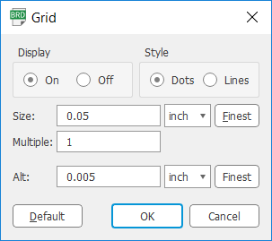
   2. Click on the “Polygon” icon .
   3. Click on the “Layer:” selector dropdown menu to select layer 16 or the bottom layer. This will assign our polygon to the bottom layer.  
        
      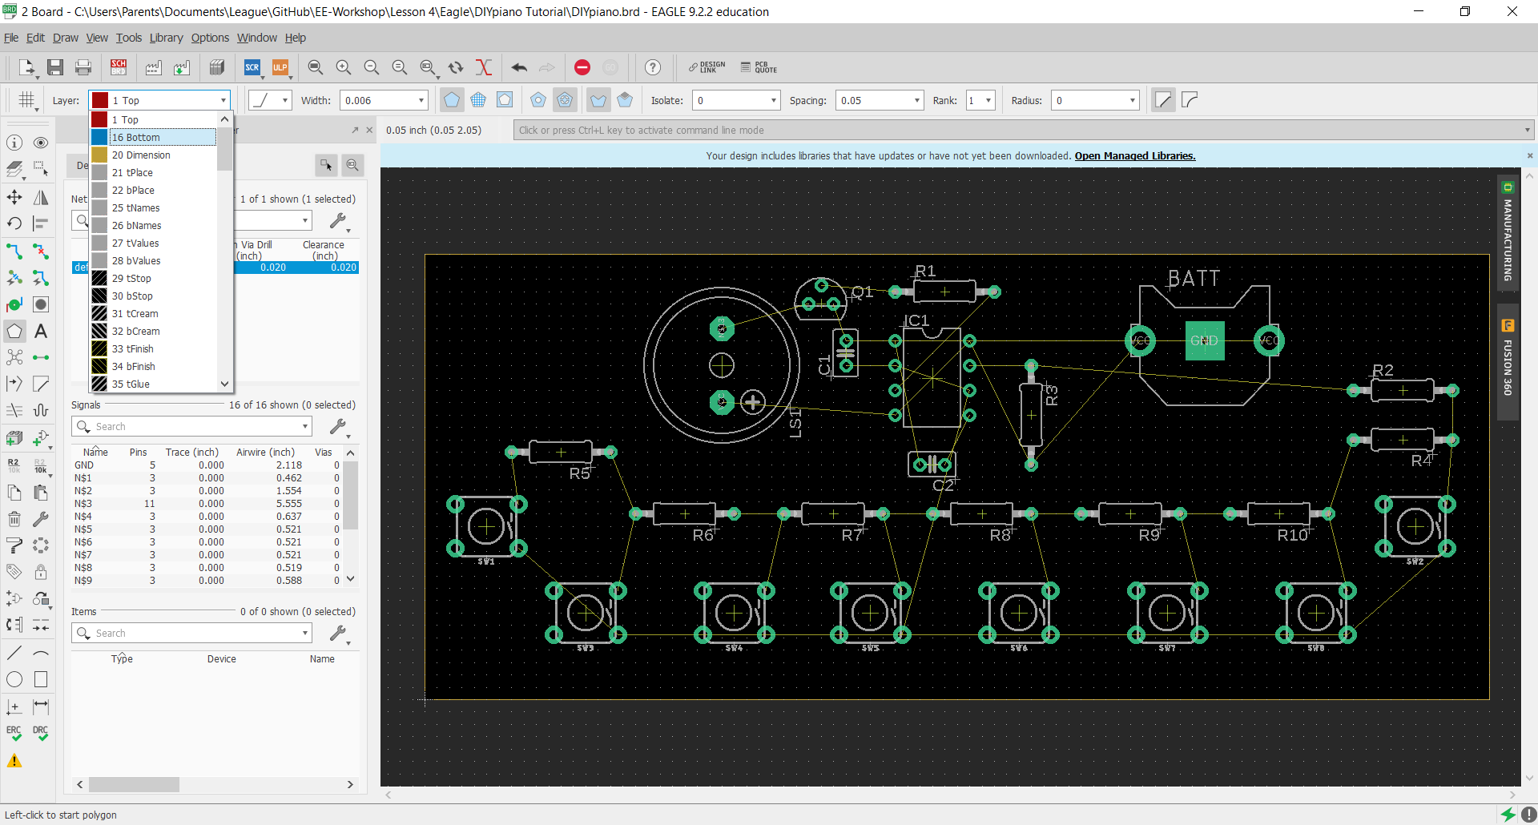
   4. Now, draw a rectangle around the board.  
        
      *Note that the color of the polygon outline is the same as the selected bottom layer.*
   5. Once the outline is complete, a dialogue window will appear asking you the signal name for this polygon. Type in “GND” and press “OK”.  
        
      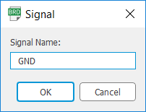  
        
      *Note that once the rectangle is complete, the outline of the pour will be displayed as a dashed line.*  
        
      Your board should look similar to the one below.  
        
      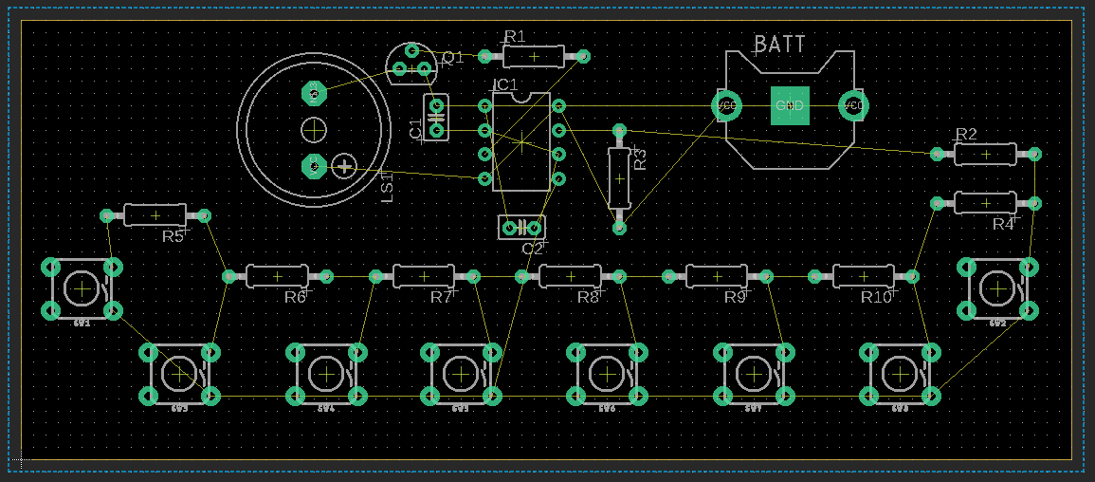
   6. Click on the “Ratsnest” icon . This will turn on the ground pour. Your design should look similar to the one below.  
        
      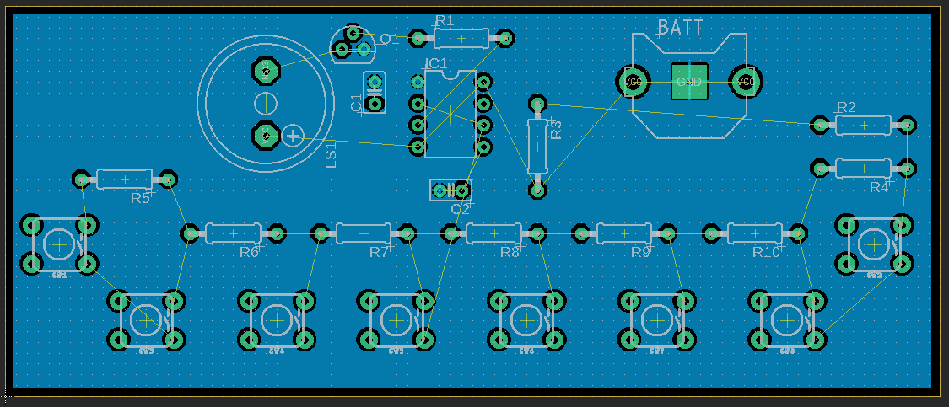
4. Moving component names  
   At this point, if so desired, you can move or rotate component names to make the board look cleaner. For example, to rotate and move LS1 for the speaker, follow the steps below.
   1. Click on the move icon and click on the crosshair handle of the component name “LS1” .
   2. In order to rotate the name, right click the mouse.
   3. Once happy with the orientation and location of the name, place it by left clicking the mouse. Speaker component name, LS1, should now look similar to the image below.  
        
      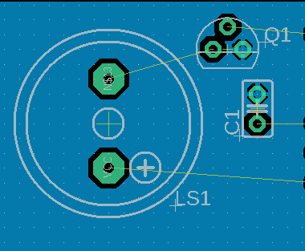
5. Auto-routing  
   We are finally at the point that we can route the board. “Routing” refers to the action of laying out the traces for the nets between components. This can be done manually, or in the case of our simple board, automatically.  
   Before we start the auto-router, however, we have to define some rules so that the tool knows how to perform the task. The following steps guide you through setting the rules and then auto-routing the design.
   1. Click on the “Edit” menu and select “Net Classes…” This will open the “Net Classes” dialogue window.  
        
      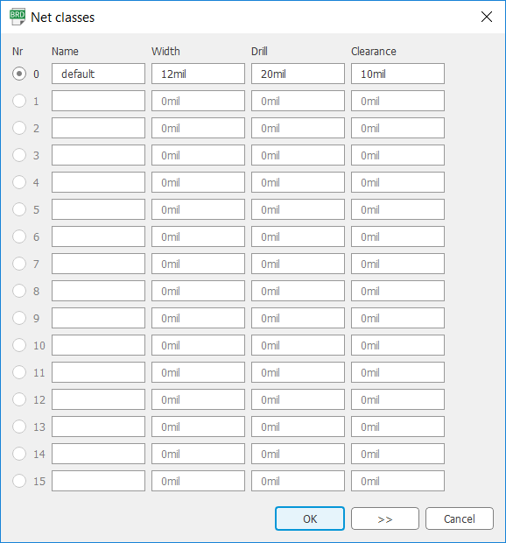
   2. For our simple design, we have only one default “Net Class” defined. Net classes set the rules for how wide the thickness of all the traces in that class should be, or how much the clearance should be between any net in that class to anything else. For our default net class, we are setting the Width to 12mil, Drill size to 20mil and Clearance to 10mil.
   3. Now, click on the “Autorouter” icon .
   4. This will open the “Autorouter Main Setup” dialogue window. In here set
      1. The top “Preferred Directions” to vertical | and the bottom “Preferred Directions” to horizontal -.
      2. The “Effort” to “High”
      3. Uncheck “Auto grid selection”, and set “Routing Grid” to 10mil. This will allow the auto router to push things around to as close as 10mils.
      4. “Maximum number of running threads” to 4.  
           
         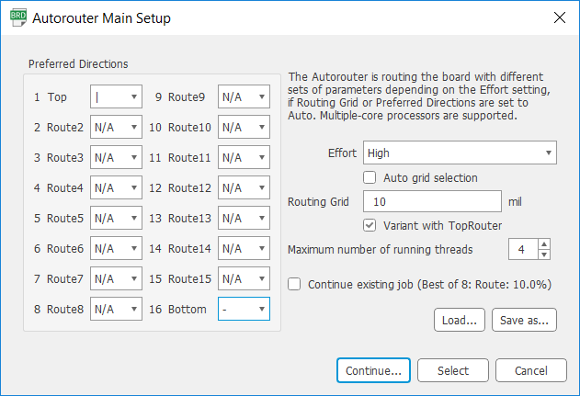
   5. Click “Continue”. This will open the “Routing Variants Dialog” window showing a number of routing tasks.  
        
      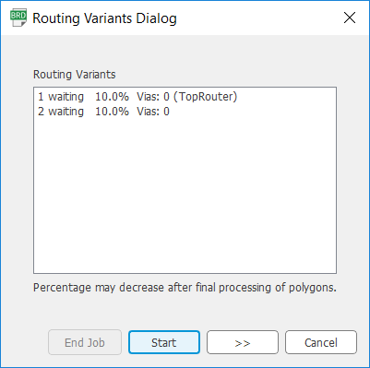
   6. Click “Start”.
   7. Once the tool has shown all the routing efforts “100.0%” complete, you can click on each candidate to see the actual routing of the board.
   8. Click on the one you prefer, and click “End Job”. Your final design should look similar to the one below.  
        
      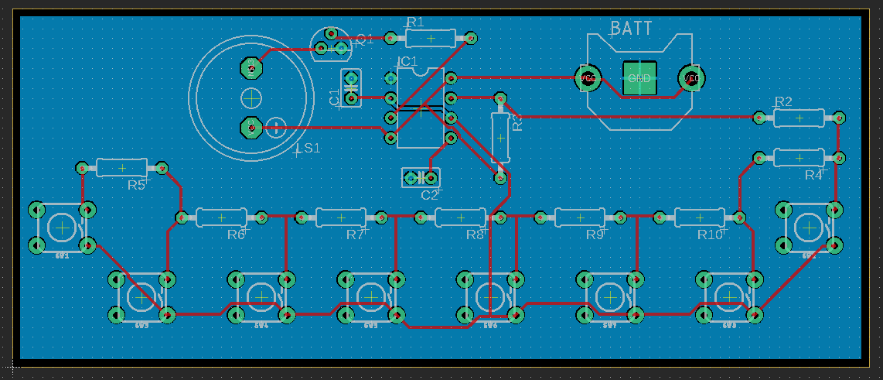
6. Placing your name on the board  
   To personalize your board, you can create a text on the tPlace layer of the board and place it at the location of your choosing.
   1. Click on the “Text” icon . This will open the “Text” dialogue window.  
        
      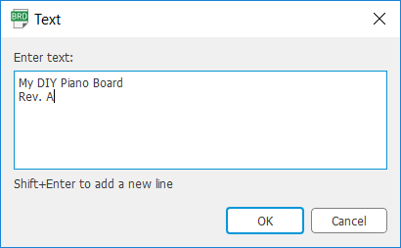
   2. Type in the text you like. To enter a new line, use “Shift+Enter”. Once you are happy with the text, click “OK”.
   3. You might notice that the text is red, the color of the top layer. To change the layer of this text to “tPlace”, click on the “Layer:” dropdown menu, and select “tPlace”. You notice that the color of the text changes to that of the “tPlace” layer, white.
   4. Move the text on a location of your choosing on the board and left click to place it.
   5. Press “ESC” and cancel to end the text placement. Now your design should look similar to the one below.  
        
      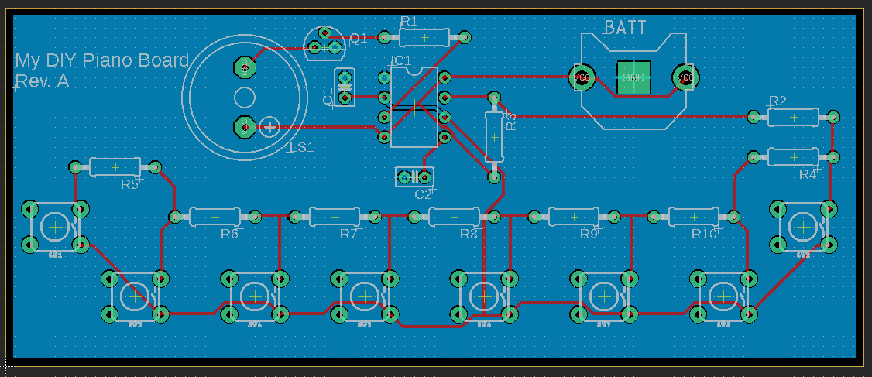
7. Adding mounting holes  
   We will now add a few mounting holes to our design so that we can mount it to an enclosure if desired.
   1. Click on the “Hole” icon .
   2. Select the size of the hole by clicking on the “Drill:” dropdown menu and selecting the appropriate hole size. For our example, we leave the hole size at 0.01377953.
   3. Move the hole to each corner of the board and left click to place a hole.
   4. Hit “ESC” to end the placement and click on the “Ratsnest” icon to see the openings for the holes on the board.
8. Renumbering the parts  
   When you designed your schematics and placed the parts, the numbering of the component might not match any particular order. You might have a resistor labeled R1 next to another one labeled R6. In order to make the part numbers flow more regularly from the top left corner down to the bottom right corner of the board, we will use a simple script to renumber the parts on the board.
   1. Click on the “ULP” icon  and select “cmd-renumber” from the list of ULPs.  
        
      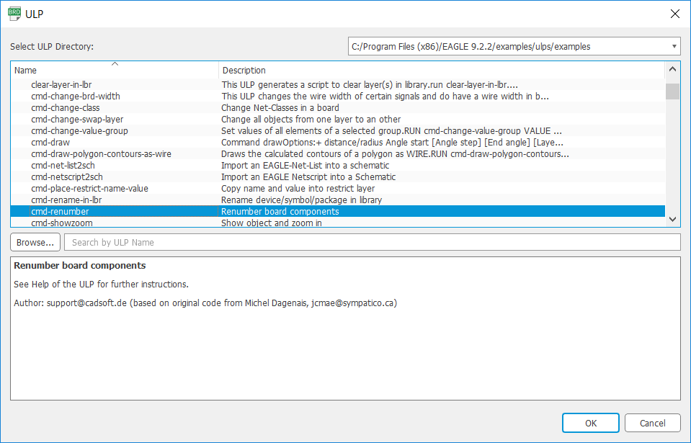
   2. Click “OK”. This will open the “Eagle: Renumber Components” window.  
        
      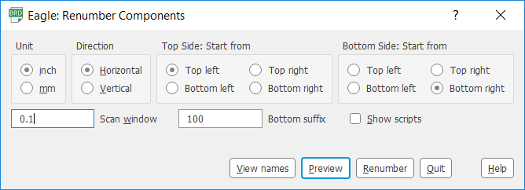
   3. Select the following
      1. Units in inch
      2. Direction: Horizontal
      3. Top Side: Start from “Top left”
      4. Bottom Side: Start from “Bottom right”
      5. Scan window 0.1
   4. Click “Renumber” and “OK” to finish.  
      This process turns off a number of the layers. Turn them back on, and your design should similar to the one below.  
        
      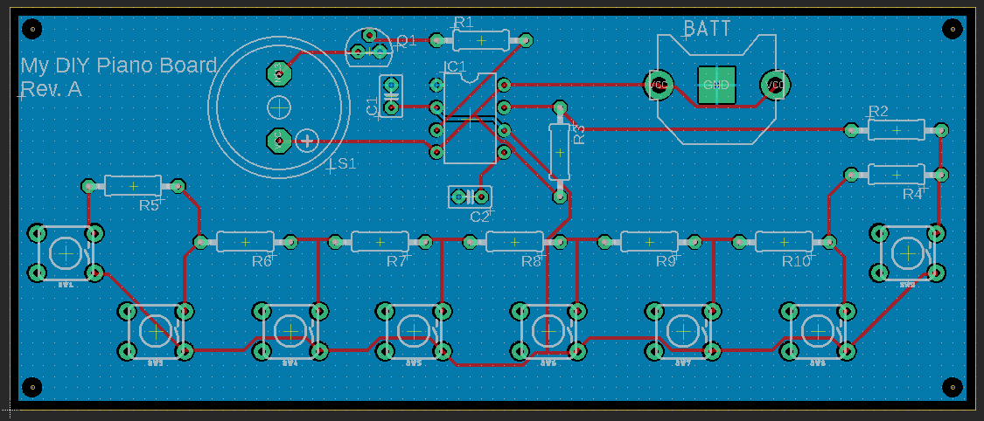
9. Design rule check  
   In order to make sure we have not made any errors in creating a layout of our board, we need to run the “Design Rule Check” or DRC. This will check the design against some design rules. We can specify the design rule as part of this process.
   1. Click on the “DRC” icon . This will open the “Design Rule Check” dialogue window.  
        
      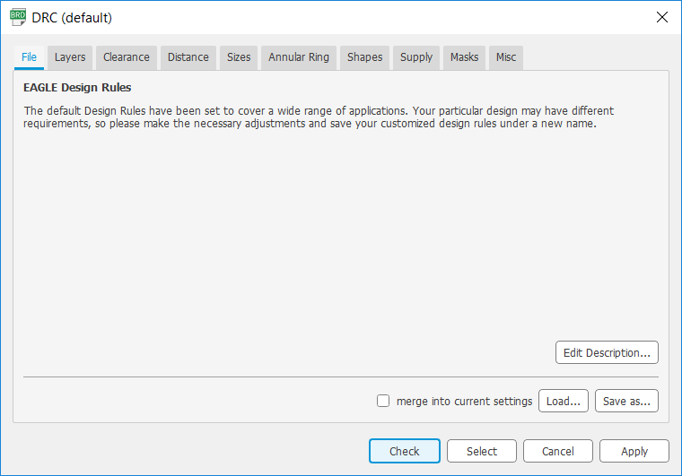  
        
      The various tabs in this window provide the various rules to be set. For our simple design, we will use the default settings.
   2. Click “Check”. You should see the message “DRC: No errors” at the bottom of the window.

You are now done creating the board layout for your design. The next step is to create the necessary files to send out to the manufacturing house for fabricating your board.

## Appendix – Useful Links

Schematic capture in Eagle:

<https://www.youtube.com/watch?v=1AXwjZoyNno>

Laying out a board in Eagle:

<https://www.youtube.com/watch?v=CCTs0mNXY24>